Action | Name | Date
Updated | Pranjal | 21-06-2021
Reviewed | Keshav | 28-07-2021
Choose an item.
Choose an item.
Choose an item.
Choose an item.

Chapter Thumbnail | Congruence of Triangles
Topic Thumbnail | Congruency Criteria

Plag% | 0%
Reading score | 87.7

Topic thumbnail
https://www.google.com/search?q=congruence+of+triangles+v&tbm=isch&ved=2ahUKEwj8x4Swvp7xAhUXXisKHYLqC24Q2-cCegQIABAA&oq=congruence+of+triangles+v&gs_lcp=CgNpbWcQA1AAWABgrwFoAHAAeACAAQCIAQCSAQCYAQCqAQtnd3Mtd2l6LWltZw&sclient=img&ei=qifLYPzKHZe8rQGC1a_wBg#imgrc=zDyJ5f-wL7-U1M (Only triangles NO TEXT)

Introduction
We have seen many triangular shapes in our day-to-day life like railing of bridges for support, triangular frames of building, etc. Are these figures congruent?
Every time we cannot use superimposition method to check the congruency of the triangles. Then, how will we do it?
Let’s discuss it.
We know that if two triangles have all the corresponding sides equal and all the included angles equal then the triangles are congruent. Such triangles look identical to each other and if positioned well, then, they will coincide each other.
There are four basic rules of congruency that are needed to be followed and if any one of the four rules stand true then those triangles will be congruent.
- SSS (Side-Side-Side)
- SAS (Side-Angle-Side)
- ASA (Angel-Side-Angle)
- RHS (Right Angle-Hypotenuse-Side)
Let’s understand each criterion one by one in detail.
https://cdn.britannica.com/74/22074-050-04A1F97E/truss-bridge-forces-lines-tension-compression.jpg (Only image no TEXT)
https://qph.fs.quoracdn.net/main-qimg-a83b5caabc84a23287c363cabcf3a421.webp
SSS Criteria
Two friends are playing a game of constructing a toy with three sticks. They need to draw the same toy. The first friend completed his toys by joining the sticks but the second friend didn’t know how to make it. First one helped him and told the lengths of sticks which were 4 cm, 6 cm and 7 cm.
Then, the second friend also completed with the help of these same dimensions. Are these toys congruent?
We know if all three sides of one triangle are the same in measure to the three corresponding sides of another triangle, then the triangles are congruent.
This criterion is called SSS criteria.
Here, SSS represents side-side-side.
Hence, both toys are congruent by SSS criteria.
Let’s take an example.
Find the congruency relation of given triangles in the image.
In the given figure,
AB = 4.5 cm = PR
BC = 7.1 cm = PQ
AC = 6 cm = QR
Since all the three sides of triangle ABC are equal to the corresponding sides of triangle RPQ. Therefore, by SSS congruence rule, the two triangles, ABC and RPQ are congruent.
That is, ΔABC ≅ ΔRPQ
Let’s move to the next criterion.
http://prnt.sc/15p3omt
SAS Criteria
A question is given by a teacher to the students to establish a relation between two triangles given in the figure.
On the next day only one student answers the question. The student said the given triangles are congruent.
Teacher asked How?
He replied, “If two sides and the angle included between them of a triangle are equal to the two corresponding sides and angle included between them of another triangle, then the triangles are called congruent.”
Hence, this criterion is called SAS.
Here, SAS represents side-angle-side.
His solution of that question is given as:
In the given figure,
AB = 8 cm = PQ
BC = 7 cm = QR
∠B = ∠Q = 40°
Therefore, the length of two sides and the included angle of triangle ABC are equal to corresponding sides and angle of triangle PQR.
So, triangle ABC is congruent to triangle PQR.
We can write, ΔABC ≅ ΔPQR
Two criterions are complete. Let’s move to the third one.
http://prnt.sc/15p3rra
ASA Criteria
Consider the following two triangular field shown in the figure.
Can you guess the relation between them?
Here we can see that:
∠XYZ = 70° = ∠FGE and ∠XZY = 50° = ∠FEG.
Along with the two angles, side YZ is equal to side GE. So, here we have 2 equal angles and the included side also equal.
So, are they congruent?
Let’s understand
ASA Congruence Rule
ASA congruence rule states that if two angles and the included side between these two angles, are equal to corresponding two angles and the side contained between them of another triangle then the two triangles will be congruent to each other.
Hence, ∆XYZ ≅ ∆FGE
Let’s move to the last criteria of congruency.
http://prnt.sc/15p3tvx
RHS Criteria
In a room, there are two ladders placed against the two walls as shown in the figure.
Ladder PR is placed against the wall PQ and ladder MO is placed against the wall MN.
Here we can see that there are two right-angled triangles, PQR and MNO.
Can you find any relation between them?
PQ = MN
MO = PR (hypotenuse of both triangles)
What can be said?
Let’s have a look on the definition.
RHS Congruence Rule
The RHS rule states that if in two right-angled triangles, the length of the hypotenuse and one side of the first triangle, is equal to the length of the hypotenuse and the corresponding side of the second triangle, then the two triangles are said to be congruent.
Therefore, ∆PQR ≅ ∆MNO
Let’s solve some examples based on these criteria.
http://prnt.sc/15p3wot
Apply the Concept!
Example 1:
Prove that in the given figure QR bisects ∠PQS.
First, we would show that both the triangles, PQR and SQR are congruent.
PQ = QS (given)
PR = RS (given)
QR = QR (common)
Therefore, by SSS criteria ∆PQR ≅ ∆SQR
Hence, ∠PQR = ∠SQR (by Corresponding parts of congruent triangles - CPCT)
It means QR bisects ∠PQS.
http://prnt.sc/15p3z5y
Example 2:
In the given figure, is ∆MNO ≅ ∆PON or ∆MNO ≅ ∆ONP?
http://prnt.sc/15p4378
In ∆MNO and ∆PON
MO = PN (hypotenuse)
NO = NO (common)
Therefore, by RHS criteria ∆MNO ≅ ∆PON
Also, ∆MNO cannot be said to be congruent to ∆ONP because in this congruency the given correspondence is not satisfied.
That is, if ∆MNO ≅ ∆ONP then by CPCT we get NO = NP which is wrong.
Did you know?
The congruence of triangles is a major operation that is used in the field of architecture. The big roofs like that of an airport or beautiful buildings use this concept in their structural design and equal distribution of the weight of the structure.

Common Errors
Incorrect | In the given figure, ∆ABC ≅ ∆PQR by ASA criteria.  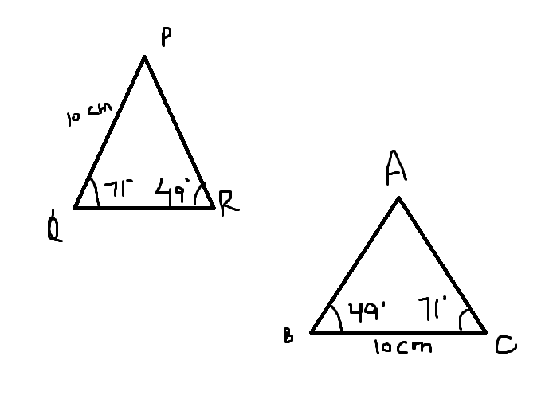 | In the given figure, ∆XYZ ≅ ∆DEF by SAS criteria.  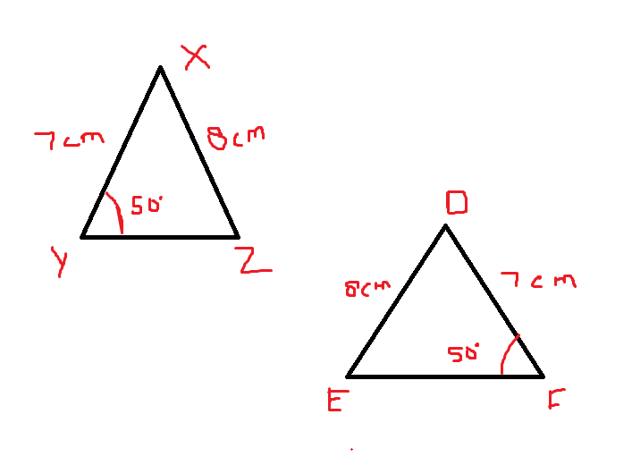
Correct | ∆ABC and ∆PQR are not congruent by ASA criteria. | ∆XYZ and ∆DEF are not congruent by SAS criteria.
Reason | Although, two angles and one side of one triangle is equal to the two angles and a side of another triangle but they are not congruent. Because, ASA states that two triangles are congruent if the included sides between two equal angles are equal.  Here, PQ is not included between two angles. | Although, two sides and an angle of one triangle is equal to the two sides and an angle of another triangle but they are not congruent. Because, SAS states that two triangles are congruent if included angles between two equal sides are equal.  Here, ∠XYZ and ∠DFE are not included between two equal sides.

Q&A
Let’s keep the grey cells ticking by answering the questions below
Question 1:
What is the expanded form for the ASA congruency rule?
Angle-Side-Angle
Question 2:
Define RHS congruency.
The RHS rule states that if in two right-angled triangles, the length of the hypotenuse and one side of the first triangle, is equal to the length of the hypotenuse and corresponding side of the second triangle, then the two triangles are said to be congruent.
Question 3:
Which sides are considered for applying the ASA congruence rule?
The included side between the two angles of one triangle and the side between the corresponding equal angles of the other triangles are considered.
Question 4:
Check whether the following two triangles ABC and DEF are congruent or not.
AB = 10 cm, BC = 8 cm, CA = 12 cm and DE = 12 cm, EF = 8 cm, FD = 10 cm
AB = 10 cm = FD
BC = 8 cm = EF
CA = 12 cm = DE
Therefore, by SSS criteria ∆ABC ≅ ∆DFE
Question 5:
Find the value of ∠CAT if in ∆CAT and ∆AOT, CT = TO, ∠CTA = ∠OTA and ∠OAT = 60°.
CT = TO
∠CTA = ∠OTA
AT = AT (common)
Therefore, by SAS criteria ∆CTA ≅ ∆OTA
Hence, ∠OAT = ∠CAT = 60° (by CPCT)

